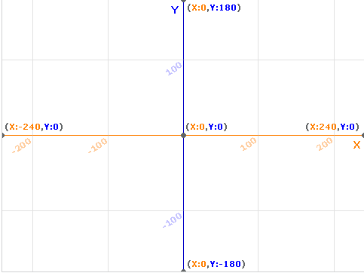
- Најпре обележи ове тачке на координатном систему
2. Убаци слику позадине координатног система xy-grid а онда испробај команде

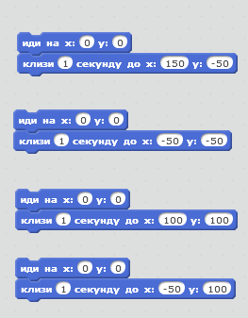
А (100,100)
B(100,-100)
C (-100,100)
D (-100,-100)
Е(50,50)
F(50,100)
G(-100,180)
I(100,180)
J(-100,180)

